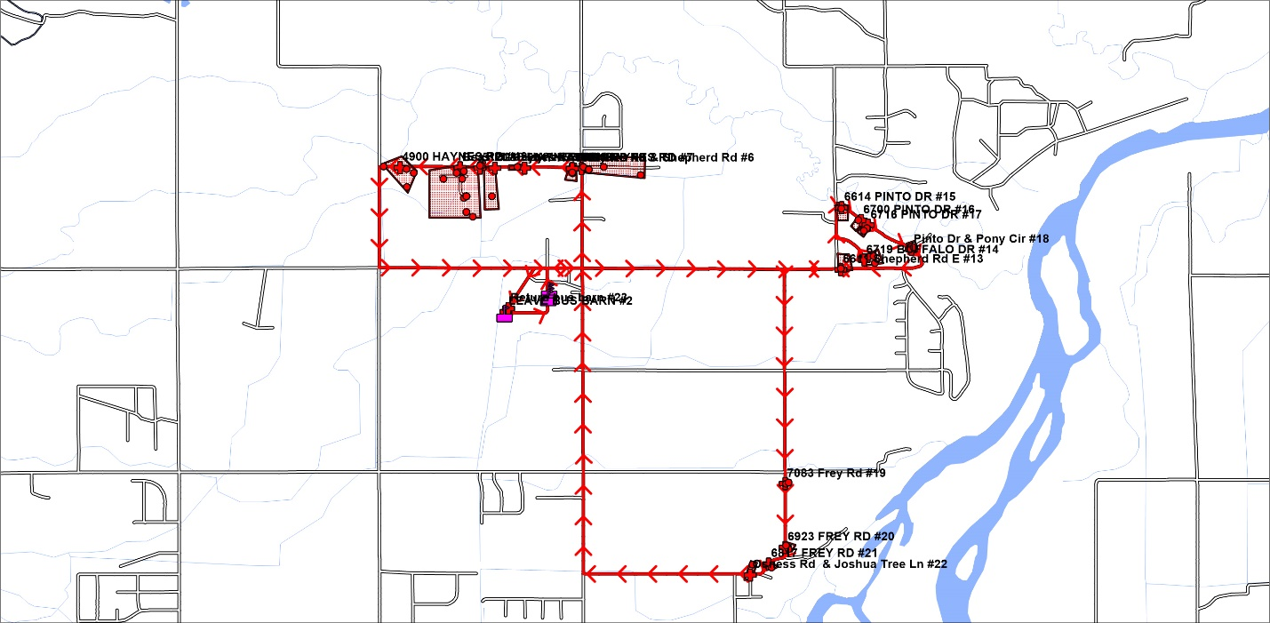

**Shepherd Bus Route 1**

**22 Miles Per Day**